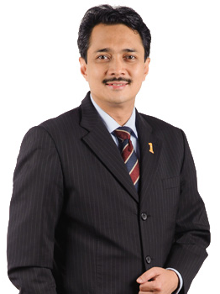

Y.BHG. DATO’ MOHD IZANI GHANI

Pengarah Eksekutif
Khazanah Nasional Berhad
Level 33, Tower 2, Petronas Twin Towers, Kuala Lumpur City Centre
50088 Kuala Lumpur

(Non-Independent Non-Executive)
Y.Bhg. Dato' Mohd Izani bin Ghani was appointed to the Board of MAHB as a Non-Independent Non-Executive Director on 21 March 2011. He is a member of Board Audit Committee, Board Finance & Investment Committee and Board Nomination & Remuneration Committee of MAHB.
Y.Bhg. Dato' Mohd Izani graduated from the London School of Economics and Political Science (LSE), United Kingdom in 1991 with Bachelor of Science (Economics) specialising in Accounting and Finance. After graduating from LSE, he pursued his professional accounting qualification from the Association of Chartered Certified Accountant and admitted to fellowship in 1998. He is also a member of Malaysian Institute of Accountants. He is currently the Executive Director and Chief Financial Officer of Khazanah Nasional Berhad (Khazanah). On cross border financing transactions, he was instrumental in the issuance of the world's first exchangeable sukuk for USD750 million in 2006, followed by other landmark exchangeable sukuk in 2007 and 2008. In relation to domestic ringgit funding, he was deeply involved in the setting up of various sukuk programmes. He is a Director of Bank Muamalat Malaysia Berhad and also sits on the Board of several special purpose companies which are wholly-owned by Khazanah , i.e. Rantau Abang Capital Berhad, Feringghi Capital Ltd, Klebang Capital Ltd, Lido Capital Ltd and Cenang Capital Ltd.

